# AML Assignment 3

William Scott | MT18026

## Dataset:

* Yale Face Dataset B is a dataset in which faces of 29 people were captured from different angles and illuminations.
* For question 1, we are considering only 10 classes (faces of people) giving us around 5706 images.

## Question 1

### K-SVD Dictionary Learning:

* In K-SVD, dictionaries are learned for sparse representations using singular value decomposition.

### Min (D, X) || Y - DX ||

* In this method, we iteratively alternate the original data and the sparse representation to learn the dictionary.
* The images that are learned are resized to 100*100 for better runtime.
* The weights are initialized randomly for this question
* Atoms in the dictionary: 1000
* Iterations: 10

### Final Learned Dictionary:

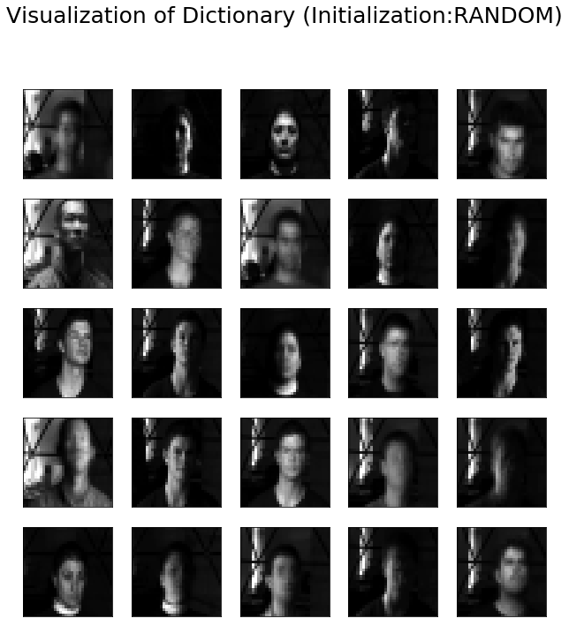

### Error:

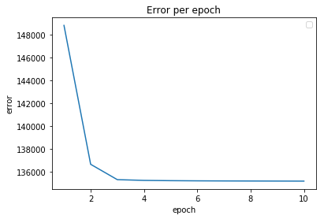

### Observations:

* Dictionary learning has a smooth gradual decrease.
* Converges in 8 epochs.

## Question 2 | Transform Learning:

* In transform learning, instead of learning a dictionary D, we will learn a Transform T

### Min(T, Z) || TX - Z ||

* Transfer learning is much more useful in any analysis framework, whereas dictionary learning can be more useful in synthesis framework.

### Error:

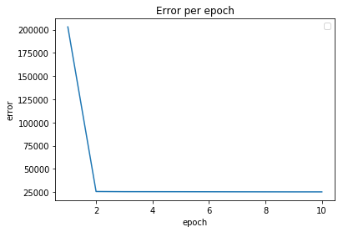

### Learned Dictionary:



### Observations:

* Dictionary learning error reduces gradually whereas the transform learning has a sharp decrease in the error.
* Transform learning converges faster.
* Number of iterations for convergence: 6

## Question 3 | Transfer Learning Framework.

* Generally, Transfer Learning is a technique to use the information gained by a particular trained model to be applied on another newer model. (Mostly weights)
* In Dictionary Learning, Transform Learning can be applied for the dictionary as we will be taking the information from the previous dictionary learned.
* We can basically initialize the newer model with the previous dictionary.
* [This Paper](http://proceedings.mlr.press/v28/maurer13.pdf) has shown a framework in which the sparse codings of the pretrained model to use on the newer model.
* For instance, if we have trained on a set of classes (faces) on the previous model and now we want to train the newer set of faces with less effort we can apply this kind of technique.

### New Dataset:

* Another set of 5 faces.
* 2925 Images.

### Initialised Dictionary:

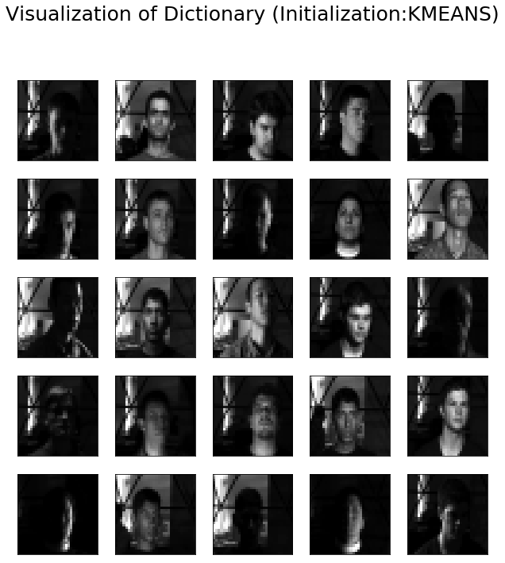

### Learned Dictionary:

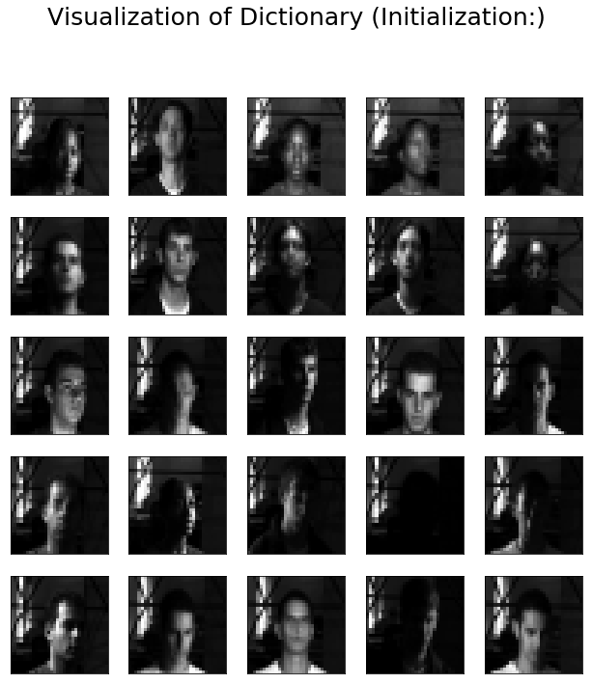

### Error:

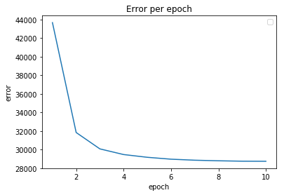

### Observations:

* Performance Measure: 1.0
* Convergence epochs: 6
* Convergence is faster and smooth.
* Using the previous domain knowledge helped generate a better dictionary.

## Question 5 | Analysis and Comparison:

### Recognition Performance:

* It is observed that Dictionary Learning performed better in all the cases, as in the transform learning we will be just using the transform T.
* And i have implemented multiple modes of initialization which proves that random data point initialization is the best. And glorot is much better than the random point initiations.
* Random initialization is taken by considering a gaussian random variable.

|  |  |  |
| --- | --- | --- |
| **Initialization Technique** | **Dictionary Learning** | **Transform Learning** |
| **Random** | 0.873 | 0.592 |
| **Random Data points** | 0.984 | 0.719 |
| **Glorot** | 0.884 | 0.689 |

### Convergence Analysis:

* As observed from the lower table, we can clearly state that transform learning converges faster as it will learn a representation along with X as TX, instead of the sparse codes as DZ in Dictionary Learning.
* All the models are run in single core without GPU.

|  |  |  |
| --- | --- | --- |
| **Initialization Technique** | Dictionary Learning | Transform Learning |
| Random points | 6 (3 Hours) | 5 (2 Hours) |
| Random Data points | 7 (4 Hours) | 3 (1 Hours) |
| Glorot Technique | 9 (5.5 Hours) | 4 (1.5 Hours) |

### Convergence Epochs:

|  |  |  |
| --- | --- | --- |
| Initialization | Dictionary Learning | Transform Learning |
| Random |  |  |
| Random Data Points |  |  |
| Glorot Initialisation |  |  |